ST DAVID’S DAY DISPATCH, March 4-5

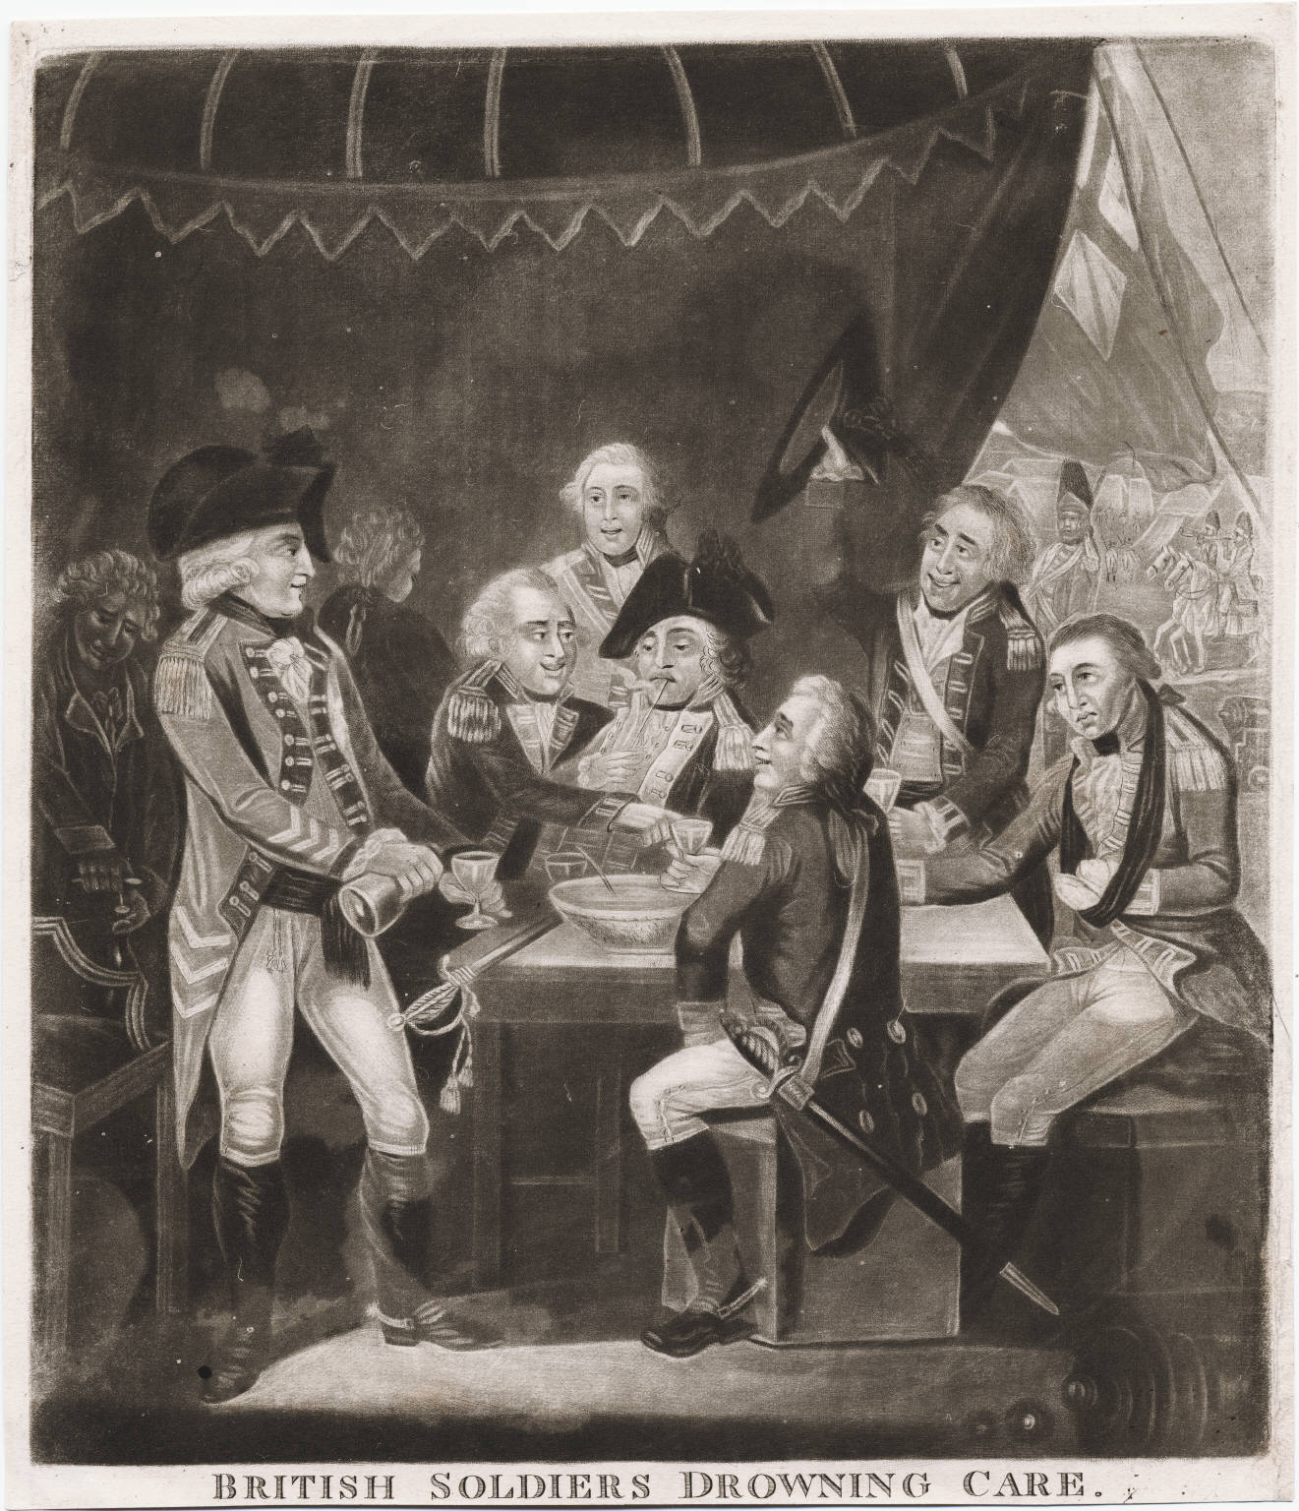
This year’s celebration is at the Old Barracks Museum located in Trenton, in the Province of New Jersey. It is located between 45-60 minutes north of Philadelphia and two hours south of New York City.
Fusiliers are asked to bring their 1768 kit and first formation is one hour prior to midday on Saturday. During the day, men will practice marching maneuvers, musket drill (with no cartridge), posting of sentries and other military practices. The evening will consist of our St. David’s Day celebration and jollification. Fusiliers can stay overnight at the Barracks (which is included in the payment for the dinner), but there are other Inns located nearby for those who wish for more comfortable quarters. A local merchant approved by the King’s commissary agents is providing rations. The cost for meal and lodging is $27.00, payable to the Regimental Adjutant.

I am with great regard,
Major S.P. Reilly

St. David’s Day Dinner Reservation Form

Name:______________________________________

Company:____________________________________

E-mail:_______________________________________

Are you planning on staying at the Barracks:** Yes:_______ No:________

Please make a $27.00 check (per person) payable to “Royal Welch Fusiliers in America” and mail it to Lieut. David Leslie-Hughes, P.O. Box 73, Mechanicsville, PA 18934.

Please print this out and mail along with the check so that it arrives by February 15th.

**-- If you plan on quartering at the tavern overnight, you need to bring your own blankets and toothbrush, spirits are also welcome--

